Web service testing

# Web service:

A **Web service** is a service offered by an electronic device to another electronic device, communicating with each other via the World Wide Web.

# SOAP and REST services:

**SOAP** (**Simple Object Access Protocol**) is a protocol specification for exchanging structured information in the implementation of web services in computer networks. It uses XML Information Set for its message format, and relies on application layer protocols, most often Hypertext Transfer Protocol (HTTP) or Simple Mail Transfer Protocol (SMTP), for message negotiation and transmission.

**REST** stands for Representational State Transfer, which is an architectural style for networked hypermedia applications, it is primarily used to build **Web services** that are lightweight, maintainable, and scalable. A **service** based on **REST**is called a **RESTful service**.

# Web service testing:

A web service can be as simple as returning the data from database whenever user sends a request to the particular endpoint or it may take input data from user and perform different validations and business logics and return response as per the implementation. Example: A web service for currency conversion, which takes two currency code as input and returns the conversion rate.

Basically a web service takes user input and perform different actions (like insert it into database/retrieve data/delete data) as per the implementation. Different operations performed by web service on a set of data in database are divided into: **C**reate/**R**ead/**U**pdate/**D**elete/**L**ist.

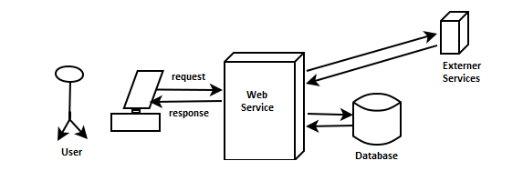

The test which validates the correctness of these operation will run a particular operation and validate the results with the requirement.

For example: An operation “**UserCreate**” has requirement which specify that this operation will take particular inputs *(FirstaName and LastName)* from user and store them into USER table in database. The manual test which validates this will run the operation with input data *(FirstaName and LastName)* and validates whether that particular user data is created in USER table in database. And an automation test will perform the same actions with the help of different tools and scripts.

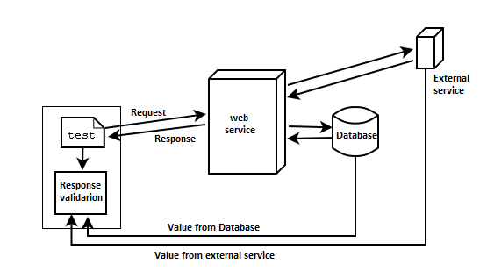

# Manual testing of web services:



Manual testing of any web service involve sending the request to specified endpoint URL and analyzing the response. Response validation could be done manually by inspecting the data inserted in the database. This process might take long time to run huge number of regression tests and analyzing the response, but it is very effective process for smoke test to quickly run and analyze the response.

As this process is time bound, we cannot consider running regression tests manually which involve running of hundreds of tests in different test environments and for different user roles. To ease the regression test execution we need to automate these tests and configure them to run continuously against the specified test environment. See, how we automate our tests in the next topic.

# Test automation using open source SoapUI:



Automating any test involves converting manually work done to be performed by tools with the help of different programing languages/scripts. Most of the advanced tools may provide features to automate different scenarios without the need to any code/script.

# Test automation using SoapUI/ SoapUI Pro:

There are many tools available in the market which support web service testing and automation. As a user of SoapUI, I’ll discuss about how to perform web service testing and automation using this tool. SoapUI comes in two different version

1. Free version - SoapUI
2. Paid version - SoapUI Pro

Both the tools can be helpful in testing and automating web services. Paid version has additional features that helps to ease the automation setup and maintenance.

# Test automation using built-in assertion:

# Data driven test automation:

# Validating results with database data:

# Case studies: